INTELLIDOCS: AN INTELLIGENT DOCUMENT EDITING SYSTEM WITH BEHAVIORAL LEARNING AND AUTOMATED FORMATTING

A Proposal Project
presented to the Faculty of the College of Computer Studies,
University of Cebu Lapu-Lapu and Mandaue

In partial Fulfillment of the Requirements
for the Degree of Bachelor of Science in Information Technology

By:
Amamence, Marjun A.
Asingua, Joshua
Alenton, Rj
Dagupan, Christian Paulo

Ms. Gian S. Mahusay
Adviser

December 2026
APPROVAL SHEET
This Capstone Project study titled IntelliDocs: An Intelligent Document Editing System with Behavioural Learning and Automated Formatting prepared and submitted by Marjun Amamence, Joshua L. Asingua, Christian Paulo Dagupan, and Rj Alenton has been examined and is recommended for approval and acceptance.

RECOMMENDED:

MS. GIAN S. MAHUSAY ALEXANDER Y. BUCOL, ED. D.EM
Adviser IT Research Coordinator
APPROVED by the Examining Tribunal on Proposal Hearing with a group verdict of on JULY 4, 2026.

ALEXANDER Y. BUCOL, ED. D.EM
Chairman

GLENDE P. BRAZIL, MIT BENEDICT M. CASTRO, MIT
Member Member

ACCEPTED and APPROVED in partial fulfillment of the requirements in Bachelor of Science in Information and Technology.
JANETTE Q. TANQUIS, DIT
Dean, CCS
Date:____________________

ACKNOWLEDGEMENT
This capstone project would not have been possible without the incredible help, collaboration, and patience of the people, organizations, and loved ones who supported the researchers throughout their journey.
Most of all, the researchers extend their most heartfelt thanks to Almighty God and Lord Jesus Christ. They express gratitude for the continual providence and protection provided during this journey. It is acknowledged that the wisdom, insight, and strength to complete this paper came from Him.
The researchers are also deeply grateful for the guidance received in conducting system evaluations; witnessing their work in action was a meaningful experience. Their research instructor offered sincere guidance from the beginning to the conclusion of the project, and the researchers are thankful for the practical advice and extensive knowledge that helped shape and refine this paper.
Special thanks go to Ms. Gian S. Mahusay, our dedicated research adviser, for her expertise and keen insights, particularly when selecting the most suitable machine learning models and predictive algorithms for the project. The researchers are appreciative of the time she devoted to reviewing and correcting their work. Her feedback was instrumental in enhancing the quality of their research.
The researchers also thank Dr. Janette Q. Tanquis, the respected Dean of the College of Computer Studies, for her continued guidance and support in bringing this study to completion.
The researchers are also grateful to their fellow researchers for stepping up to assist and for providing constant encouragement during challenging times.
Finally, the researchers express their deepest appreciation to their beloved parents, families, and friends. Their unwavering support and belief were the true keys to completing this research.
The Researchers

DEDICATION
This study is dedicated first to Almighty God. The researchers express gratitude for the wisdom, understanding, and guidance provided throughout every step of building this project, acknowledging that His presence was felt at all times.
The dedication also extends to students, professionals, and content creators who devote countless hours to drafting research papers, reports, and publications. The researchers salute their hard work and perseverance. Observing the repetitive, mechanical formatting tasks and daily inefficiencies these individuals face was a key inspiration for the creation of IntelliDocs. The researchers hope this intelligent document editing system will become a trusted companion, automating tedious formatting tasks and easing cognitive burdens.
This work is further dedicated to the researchers’ beloved alma mater, the University of Cebu Lapu-Lapu and Mandaue, the College of Computer Studies, and the faculty members who have nurtured and guided them over the years. They are thankful for the strong foundation the institution has provided for their current and future endeavors.
Above all, this project is dedicated to the researchers’ parents, family, teachers, respondents, and friends who have unconditionally supported them. Their relentless encouragement and provision sustained the researchers and motivated them to persevere until the very end. The researchers are deeply grateful for their unwavering presence.
Without the support of all these individuals and institutions, none of this would have been possible.
The Researchers
TABLE OF CONTENTS
PAGES
TITLE PAGE i
APPROVAL SHEET ii
ACKNOWLEDGEMENT iii
DEDICATION iv
TABLE OF CONTENTS v
LIST OF TABLES vii
LIST OF FIGURES viii
CHAPTER I: INTRODUCTION 1
Rationale of the Study 1
Objectives of the Study 4
Scope and Limitations 5
Significance of the Study 6
Definition of Terms 8
CHAPTER II: REVIEW OF RELATED LITERATURE AND STUDIES 11
Related Literature 11
Conceptual Framework 14
Related Studies 16
Comparative Matrix 22
CHAPTER III: RESEARCH METHODOLOGY 24
Research Design 24
Method 24
Flow of the Study 26
Research Environment 28
Respondents 29
Research Instrument 29
Research Procedure 29
Data Gathering 30
Treatment of Data 30
Software Engineering Methodology 32
Planning Conception-Initiation 35
Business Model Canvas 36
Program Workflow 38
Validation Board (Stages 1 and 2) 39
Business Roadmap 41
Functional Decomposition Diagram 42
Gantt Chart 43
Analysis-Design Phase 44
AI System Architecture 44
Use Case Diagram 46
Storyboard 60
Database Design 74
Entity-Relationship Diagram 77
Data Dictionary 78
Network Design 98
Network Model 98
Network Topology 99
Development / Construction / Build Phase 100
Technology Stack Diagram 100
Hardware Specification 101
Software Specification 102
Program Specification 103
List of Modules 104
REFERENCES 105
CURRICULUM VITAE 107
APPENDICES 113
A. Transmittal Letter 113
B. Research Environment 114
C. Survey Questionnaire 115

LIST OF TABLES
Table No. | Name | Page No.
1 | COMPARATIVE MATRIX | 22
2 | FLOW OF THE STUDY OF INTELLIDOCS | 26
3 | SCORING POINTS | 31
4 | VALIDATION BOARD | 39
5 | DATA DICTIONARY OF USERS | 78
6 | DATA DICTIONARY OF FOLDERS | 80
7 | DATA DICTIONARY OF DOCUMENTS | 81
8 | DATA DICTIONARY OF FOLDER_DOCUMENTS | 83
9 | DATA DICTIONARY OF FORMATTING_ACTIONS | 84
10 | DATA DICTIONARY OF AI_SUGGESTIONS | 86
11 | DATA DICTIONARY OF SUGGESTION_FEEDBACK | 88
12 | DATA DICTIONARY OF GRAMMAR_ISSUES | 89
13 | DATA DICTIONARY OF GOOGLE_TOKENS | 91
14 | DATA DICTIONARY OF REDIS_BEHAVIOR_BUFFER | 92
15 | DATA DICTIONARY OF REDIS_SUGGESTION_CACHE | 93
16 | DATA DICTIONARY OF REDIS_QUOTA_TRACKER | 94
17 | DATA DICTIONARY OF DUCKDB_BEHAVIOR_EVENTS | 95
18 | DATA DICTIONARY OF DUCKDB_FORMATTING_FEATURES | 96
19 | SOFTWARE SPECIFICATION | 102
20 | LIST OF MODULES | 104
LIST OF FIGURES
Figure No. | Name | Page No.
1 | CONCEPTUAL FRAMEWORK | 14
2 | SCHOLARFORMAT | 16
3 | AUTOSCI | 18
4 | ORBIT | 19
5 | KNOWLEDGELAKE | 20
6 | EVERTEAM | 21
7 | RESEARCH ENVIRONMENT IN UNIVERSITY OF CEBU LAPU-LAPU AND MANDAUE | 28
8 | AGILE (ITERATIVE-INCREMENTAL) DEVELOPMENT METHODOLOGY | 32
9 | BUSINESS MODEL CANVAS OF INTELLIDOCS | 36
10 | PROGRAM WORKFLOW OF INTELLIDOCS | 38
11 | BUSINESS MODEL CANVAS | 41
12 | FUNCTIONAL DECOMPOSITION DIAGRAM OF INTELLIDOCS | 42
13 | GANTT CHART OF PROJECT ACTIVITIES | 43
14 | AI SYSTEM ARCHITECTURE OF INTELLIDOCS | 44
15 | USE CASE DIAGRAM OF INTELLIDOCS | 46
16 | SYSTEM USE CASE MODEL – AUTHENTICATE ACCOUNT | 47
17 | SYSTEM USE CASE MODEL – MANAGE ACCOUNT | 48
18 | SYSTEM USE CASE MODEL – VIEW DOCUMENTS | 51
19 | SYSTEM USE CASE MODEL – MANAGE DOCUMENTS | 53
20 | SYSTEM USE CASE MODEL – ENGAGE CHATBOT | 55
21 | SYSTEM USE CASE MODEL – EDIT DOCUMENT CONTENT | 57
22 | LANDING PAGE | 60
23 | LOGIN | 62
24 | REGISTER | 64
25 | DASHBOARD | 66
26 | MY DOCUMENTS | 68
27 | DOCUMENT EDITOR | 70
28 | TRASH | 72
29 | SUPABASE DATABASE DESIGN | 74
30 | REDIS DATABASE DESIGN | 75
31 | DUCKDB DATABASE DESIGN | 75
32 | ENTITY-RELATIONSHIP DIAGRAM OF INTELLIDOCS | 77
33 | NETWORK DESIGN OF INTELLIDOCS | 98
34 | NETWORK MODEL OF INTELLIDOCS | 98
35 | NETWORK TOPOLOGY OF INTELLIDOCS | 99
36 | TECHNOLOGIES USED IN THE DEVELOPMENT OF INTELLIDOCS | 100
37 | RESEARCH ENVIRONMENT IN UNIVERSITY OF CEBU LAPU-LAPU AND MANDAUE | 114

CHAPTER I

INTRODUCTION

Rationale of the Study
Document creation is a cornerstone of academic, professional, and personal productivity in the digital era. Whether drafting research papers, business reports, or everyday communications, individuals across the globe rely on digital tools to generate, format, and share information. The efficiency and quality of this process directly influence learning outcomes, job performance, and the dissemination of knowledge. However, despite technological advances, much of the document creation process remains hampered by repetitive and time-consuming formatting tasks (Zon & Boisvert, 2021).
A review of manuscript submission practices found that reformatting papers for resubmission to different journals accounts for an estimated 23.8 million hours spent by researchers worldwide annually, at a potential cost of $1.1 billion USD (Zon & Boisvert, 2021). This inefficiency translates into a significant loss of productivity each year, underscoring a systemic issue that extends far beyond academia. The burden is not limited to scholarly work: legal, business, and administrative professionals also spend considerable time on formatting, with estimates suggesting a substantial share of document preparation involves repetitive layout and styling activities (Lawve.ai, 2026).
The digitalization of education and work has further highlighted the importance of efficient document creation. In the Philippines, the COVID-19 pandemic accelerated the shift to remote learning and digital submission of assignments, compelling institutions to adopt and adapt new technologies at an unprecedented rate (Barrot, Llenares, & Del Rosario, 2021). While this transformation has opened new opportunities, it has also exposed existing gaps and created new challenges. Filipino educators and students, for instance, are often required to comply with strict formatting standards for theses, reports, and digital portfolios. Adherence to these guidelines is critical for institutional quality assurance, yet the process is frequently manual, error-prone, and stressful (Barrot, Llenares, & Del Rosario, 2021).
Despite the availability of powerful document editing platforms such as Microsoft Word and Google Docs, these tools are fundamentally limited by their reliance on user-driven templates and manually applied styles (Miraz, Ali, & Excell, 2022). Templates may provide a starting point, but they do not adapt dynamically to user preferences or institutional requirements. As a result, users spend countless hours reapplying styles, checking compliance, and correcting inconsistencies—tasks that sap creativity, reduce focus, and contribute to burnout, especially when deadlines are tight or standards are high (Miraz, Ali, & Excell, 2022).
Advancements in artificial intelligence (AI) and machine learning are reshaping the landscape of writing assistance. Tools like Grammarly and ChatGPT offer sophisticated grammar correction, content generation, and style suggestions, demonstrating the transformative potential of AI in natural language processing (Stede & Marfurt, 2022; OpenAI, 2023). However, even these state-of-the-art systems primarily focus on textual accuracy and fluency, rather than the nuanced demands of document formatting and compliance with institutional guidelines. As noted by Stede and Marfurt (2022), most intelligent writing assistants cannot learn from user behaviors or adapt to specific formatting conventions, resulting in a persistent gap between user needs and tool capabilities.
These restrictions are especially noticeable in the Philippine setting, particularly at the University of Cebu Lapu-Lapu and Mandaue. Recent studies on digital transformation in local education highlight the challenge of bridging the gap between global technologies and localized requirements (Barrot, Llenares, & Del Rosario, 2021). Educators and students at UC Lapu-Lapu and Mandaue often face difficulties in adapting generic digital solutions to fit their specific curriculum, assessment protocols, and administrative standards. This misalignment not only decreases the effectiveness of technology adoption but also increases the cognitive and administrative burden on users (Barrot, Llenares, & Del Rosario, 2021).
The productivity implications of this issue are significant. Every hour spent on manual formatting is an hour taken away from critical thinking, creativity, and meaningful learning. In today's increasingly digital and competitive educational and professional environment, the ability to efficiently produce polished, standards-compliant documents is essential, not optional. The economic and psychological costs of inefficient workflows, such as lost time, reduced output, increased stress, and diminished motivation, underscore the urgent need for intelligent solutions tailored to Filipino learners and professionals, especially at the University of Cebu Lapu-Lapu and Mandaue.
Given these challenges and opportunities, this study proposes the development of IntelliDocs, a web-based intelligent document editor specifically designed to address persistent gaps in current document creation tools. The core innovations of IntelliDocs include machine-learning-driven formatting automation, a natural-language command interface for rapid bulk formatting, and a continuous-improvement system fueled by real user feedback. Unlike traditional templates or static editing tools, IntelliDocs aims to learn from user actions, adapt to institutional requirements, and deliver context-aware formatting recommendations that streamline the entire document creation process.
By embedding these features in a user-friendly, locally relevant platform, this study aspires to:
- Reduce wasted time and cognitive load associated with manual formatting,
- Enhance compliance with academic and professional standards,
- Increase productivity and satisfaction for Filipino students, educators, and professionals.

Objectives of the Study

General Objective
To design, develop, and implement a web-based intelligent document editing system that leverages machine learning to understand user formatting behaviors, automate repetitive styling tasks, and offer a natural language command interface, with continuous refinement driven by user feedback in University of Cebu Lapu-Lapu and Mandaue.
Specific Objectives
1. Analyze existing document editing systems by evaluating:
1.1. current formatting processes and workflow structures; and
1.2. common challenges, including repetitive manual formatting, lack of personalization, and limited intelligent automation.
2. Identify and integrate key mechanisms and techniques for the proposed system, specifically:
2.1. behavioral tracking of user formatting actions as sequential patterns;
2.2. machine learning-based prediction of formatting actions with confidence scoring;
2.3. a natural language command interface to enable efficient bulk formatting operations; and
2.4. continuous improvement through reinforcement learning from accepted suggestions and retraining from rejected ones.
3. Determine the most effective features to be included in the Intelligent Document Editing System, focusing on:
3.1 Core document management capabilities and;
3.2 behavioral learning and automated formatting.
4. Implement a web-based Intelligent Document Editing System that combines behavioral learning, automated formatting, and natural language interaction to provide a personalized document editing experience.
5. Assess the acceptability and effectiveness of the proposed system among target users.

Scope and Limitations of the Study
The system scope of IntelliDocs encompasses a fully integrated suite of smart features designed to transform the digital writing experience. It begins by allowing users to securely register and authenticate accounts before granting them access to a responsive, web-based document editing environment accessible directly through modern browsers. While writing, the platform actively captures and analyzes formatting behaviors as distinct sequential actions, simultaneously extracting critical contextual features such as relative text position, character length, and surrounding punctuation boundaries. These isolated metadata patterns are then fed into a hybrid machine learning prediction engine that balances rule-based logic with neural networks to generate non-intrusive, confidence-scored formatting suggestions.
To handle larger design changes efficiently, the platform includes a natural language command interface engineered specifically for executing rapid bulk formatting operations via plain text commands. The system is built as an adaptive personalization platform, meaning it incorporates continuous learning by dynamically retraining its predictive models based on direct user acceptance and rejection feedback. Finally, to protect content integrity and ensure fluid, multi-device web access, the system features a real-time auto-save functionality alongside a responsive interface that maintains consistent usability across various mobile and desktop hardware configurations.
There are a few practical constraints to consider with the current build of IntelliDocs. At this stage, the platform operates exclusively as a single-user web application, which means offline editing is not supported. The natural language interface is also narrowly focused on styling tasks rather than generating written content. Finally, the system's ability to accurately predict formatting preferences hinges on how consistently a person works. Because it takes time to learn these individual habits, users will likely experience less accurate suggestions early on while the software gathers enough training data.

Significance of the Study
The significance of this research lies in its potential to transform digital document creation by automating and personalizing formatting tasks. Unlike conventional word processors such as Google Docs and Microsoft Word, which rely heavily on manual styling and generic templates, IntelliDocs leverages machine learning and natural language commands to offer an adaptive editing experience that evolves with user behavior and preferences. This targeted approach directly addresses the inefficiencies and challenges outlined in the study's objectives and rationale, making the system particularly valuable in rapidly digitalizing contexts like the Philippines (Sevilla & Zulueta, 2021).
The findings and proposed system are expected to impact the following batches of users:
Students. Will benefit from an automated, readily available AI-driven tool that significantly reduces the time and effort spent on manual document formatting. This allows for real-time formatting assistance through personalized suggestions, timely bulk formatting via natural language commands, and a simplified, less tedious approach to preparing academic manuscripts, potentially reducing the frustration associated with repetitive styling work.
Professionals and Organizations. Can utilize the system's bulk formatting automation and adaptive learning to achieve substantial time savings and streamlined document workflows. Furthermore, they will benefit from the system's ability to ensure standardized styling and compliance with organizational guidelines, reducing formatting errors while supporting brand and institutional consistency across documents.
Academic Researchers and Writers. Can more easily organize and format complex academic documents, reducing the burden of repetitive manual editing during manuscript preparation. Implementing IntelliDocs may improve overall writing efficiency and demonstrate a practical application of adaptive AI technology in academic document preparation, allowing writers to focus more on content quality than formatting mechanics.
Researchers. Will gain invaluable practical experience in designing, developing, and implementing a complex application at the intersection of artificial intelligence, natural language processing, and document engineering. This project serves as a significant opportunity for applying theoretical knowledge, navigating technical challenges in real-time collaborative systems, and advancing programming and system development careers.
Future Researchers. Will have access to empirical data, methodological insights, and findings regarding the implementation and effectiveness of AI-driven formatting features (behavioral learning, natural language bulk editing, retrieval-augmented chatbot assistance) within an academic setting. This study provides a foundational case study and baseline data that can inform subsequent research, comparative analyses, or the development of similar intelligent document-editing systems.

DEFINITION OF TERMS
Term | Definition
Artificial Intelligence (AI) | Refers to the technology that enables the system to analyze user inputs, learn individual formatting preferences through behavioral learning, interpret natural language commands, and provide intelligent formatting suggestions.
Behavioral Tracking | The process of recording the sequence of formatting actions a user performs while editing a document, used as the basis for learning individual formatting preferences.
Bulk Formatting Operations | Formatting changes applied to multiple document elements at once through a single command, such as applying the same style to all headings simultaneously.
Cognitive Load | The mental effort a user exerts during document editing, particularly the burden caused by repetitive manual formatting tasks that intelligent automation aims to reduce.
Cold Start Problem | The initial phase of an intelligent system where insufficient user data has been collected to generate reliable predictions, resulting in lower accuracy during early usage.
Confidence Score | A percentage value displayed alongside a formatting suggestion indicating how certain the system is that the suggestion matches the user’s preference.
Contextual Features | The surrounding information captured when a formatting action is performed, such as the text’s position in the document, its length, and adjacent punctuation, used to improve prediction accuracy.
Continuous Improvement | The ongoing process by which a system refines its formatting predictions over time by learning from each user’s acceptance, rejection, or correction of suggestions.
Document Editor | The core interface of IntelliDocs where users create, view, and modify documents, integrating both manual editing tools and AI-assisted formatting features.
Embedding | A numerical vector representation of text used by the retrieval system to capture semantic meaning, enabling the chatbot to find relevant content from the uploaded reference corpus.
Feature Extraction | The step in which relevant signals are identified and isolated from user formatting actions such as text position and capitalization to be used as inputs for machine learning models.
Formatting Automation | The automatic application of formatting styles based on predictions learned from user behavior, reducing the need for users to apply styles manually and repeatedly.
Google Drive | Refers to the cloud storage service integrated into IntelliDocs for storing, synchronizing, and managing users' documents, allowing secure access across different devices.
Hybrid Machine Learning | A prediction approach that combines rule-based pattern detection with neural networks to achieve higher formatting prediction accuracy than either method alone.
IntelliDocs | A web-based intelligent document editor that learns a user's formatting behavior over time and automatically suggests appropriate formatting with a visible confidence score, reducing the need for repetitive manual formatting in academic documents.
Intent Recognition | The ability of a natural language command interface to understand what formatting action a user intends when they type an instruction in plain language.
Isolation Manager | A privacy control component that allows users to manually detach or pause behavioral loggers, preventing the system from tracking their formatting actions for a given session.
LSTM (Long Short-Term Memory) | A type of neural network suited for sequential data, enabling a system to learn from the order in which a user performs formatting actions over time.
Machine Learning | A branch of artificial intelligence that enables a system to automatically learn and improve its predictions from user behavior data, without being manually programmed for each formatting rule.
Natural Language Command Interface | A system feature that allows users to give formatting instructions by typing everyday language commands rather than navigating menus or using keyboard shortcuts.
Neural Network | A computational model that learns patterns from data through interconnected layers of processing nodes, used within a prediction engine to generate accurate formatting suggestions.
Personalization | The process by which a system adapts its formatting suggestions to fit the unique habits and preferences of each individual user based on their editing history.
Personalized Model | A machine learning model trained exclusively on a single user’s formatting history, as opposed to a general model trained on aggregated data from multiple users.
Query | A user's input, whether typed as a natural language command or a chatbot question, that the system processes to determine an appropriate response or action.
Rule-Based System | A component of a hybrid prediction engine that applies fixed logical conditions to detect known formatting patterns, complementing the neural network component.
Sequential Pattern | A series of formatting actions performed by a user in a specific order, tracked and used as a more reliable predictor of formatting intent than individual actions considered alone.

CHAPTER II

REVIEW OF RELATED LITERATURE AND STUDIES
This section examines existing research related to the core functions of IntelliDocs: behavioral tracking of user formatting actions, machine learning-based formatting prediction and automation, natural language interface for formatting commands, and the continuous improvement cycles that enable personalization through user feedback.

Behavioral Tracking & Feature Extraction
Recent scholarship underscores the critical role of tracking not only individual user actions but also the sequences and contextual features surrounding them. Barkan, Levy, and Lin (2023) demonstrated that systems observing sequential user interactions can achieve up to 87% accuracy in predicting preferences after a limited number of interactions. This finding suggests that behavioral-tracking modules, as envisioned in IntelliDocs, are well positioned to learn and automate user-specific formatting routines rapidly. Additionally, Li, Wang, and Sun (2021) reported that incorporating contextual metadata—such as text location, segment length, and preceding formatting actions—improves prediction accuracy by 24% over content-only models. These insights support the design of IntelliDocs’ feature extraction engine, which systematically captures relevant metadata to drive effective pattern recognition and personalized automation.
Machine Learning Prediction Engine
The literature strongly supports the integration of machine learning for formatting automation. Singh et al. (2023) found that hybrid systems—combining symbolic rule enumeration with a neural ranker—can effectively learn conditional formatting rules from user-provided examples, achieving strong performance as a working Excel add-in. Notably, personalization significantly enhances performance, with user-specific models outperforming generic ones. These results have directly influenced IntelliDocs' adoption of a hybrid, user-adaptive prediction engine with confidence scoring to determine whether to auto-apply or suggest formatting changes. Furthermore, Wang and Yin (2021) found that providing transparent confidence scores and explanations for AI-driven suggestions increases user trust and reliance, compared to opaque systems that offer no rationale. This evidence underpins the system's commitment to interpretability and user empowerment.
User Transparency & Suggestion Presentation
User trust and engagement are central to the successful adoption of intelligent editing systems. Wang and Yin (2021) explored factors influencing user trust and reliance in AI-assisted decision-making. Their study identified explanations and confidence information as key drivers of appropriate trust calibration, showing that users adjust their reliance on a system's suggestions based on the transparency of the information provided. They also recommended interface features such as one-click rejection of suggestions, suppression of unwanted recommendations, and timing the presentation of suggestions to coincide with natural workflow pauses. These findings inform IntelliDocs' interaction design philosophy, which prioritizes transparency, unobtrusive suggestion delivery, and a user-centric onboarding experience.

Natural Language Command Interface
Efficiency in document editing can be markedly improved by implementing natural language interfaces. Zamani and Kraus (2022) demonstrated that such interfaces enable users to complete complex formatting tasks 58% faster and with greater accuracy than traditional menu navigation. Furthermore, 84% of users preferred natural language commands, particularly for bulk or multi-step operations. These findings validate the inclusion of IntelliDocs’ natural-language command interface, which facilitates rapid, error-free execution of advanced formatting tasks.

Continuous Improvement & System Learning
Continuous learning and adaptation are recognized as essential for intelligent document editing systems. Park and Nakamura (2024) showed that systems employing ongoing user interaction and feedback can achieve substantial improvements in prediction accuracy, especially as they encounter diverse document types. Singh and Martinez (2023) and Heo and Lee (2023) further emphasized the importance of reinforcement learning, frictionless correction mechanisms, and transparent feedback loops to sustain user engagement and system evolution. Therefore, IntelliDocs incorporates reinforcement and retraining modules that leverage user acceptance and correction data to dynamically refine recommendations and personalize the user experience.
User Outcomes & Productivity Benefits
Empirical evidence consistently demonstrates the productivity benefits of machine learning-based formatting automation. Wang, Li, and Chen (2023) reported that users of ML-powered editing tools experienced a 67% reduction in formatting time and a 73% decrease in inconsistencies compared to manual editing methods. Participants also reported heightened satisfaction and greater control over their work. These outcomes resonate with the core objectives of IntelliDocs, affirming the value of intelligent automation in enhancing workflow efficiency and user satisfaction.

Conceptual Framework.
The conceptual framework for IntelliDocs focuses on delivering an intelligent document editing experience through an integrated system of features designed to learn from user behavior and automate repetitive formatting tasks. Central to this framework are components such as Behavioral Tracking & Feature Extraction, which captures sequential user actions and contextual signals to build personalized formatting profiles. Ultimately, this framework aims to improve document creation efficiency among students, professionals, and content creators by offering a user-friendly platform that prioritizes personalization, transparency, and continuous learning from user interactions.
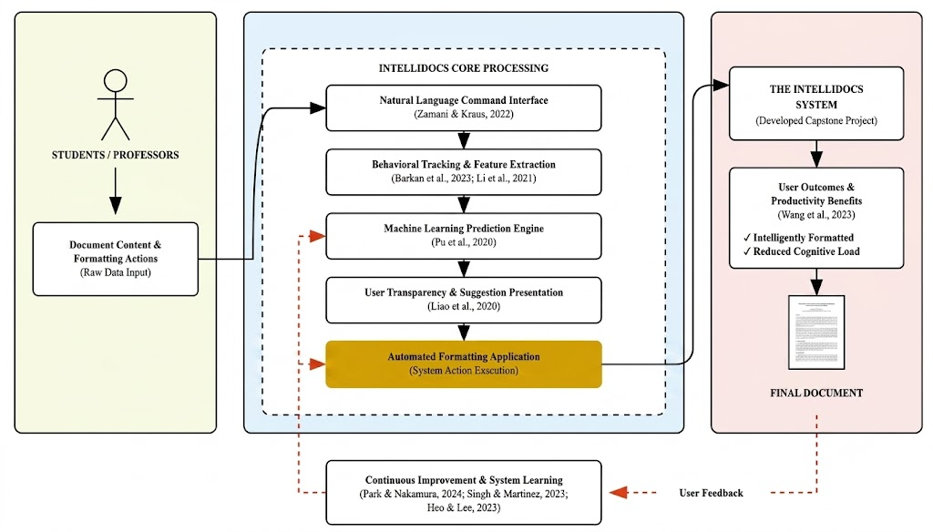
Figure 1: Conceptual Framework
The conceptual framework of IntelliDocs: An Intelligent Document Editing System with Behavioral Learning and Auto-Formatting integrates various interconnected components to address the challenges encountered in document creation and formatting. The framework begins by identifying four major problem areas: Formatting Processes and Workflows, which involve inconsistent styles and time-consuming manual edits; Cognitive Challenges, including high mental workload and difficulties in error detection; Personalization Challenges, characterized by generic recommendations and limited user adaptation; and Automation Challenges, which include limited automation capabilities and low accuracy of existing systems. To address these issues, IntelliDocs employs a Behavioral Tracking and Extraction module that captures sequential editing patterns, contextual metadata, and keystroke logging to understand users' formatting behaviors. The system then utilizes Machine Learning Prediction, incorporating rule-based logic, Long Short-Term Memory (LSTM) neural networks, and confidence scoring mechanisms to generate intelligent and personalized formatting recommendations. A User Authentication and Web-Based Information System manages user profiles for students, professionals, and content creators while maintaining personalized experiences and secure access. Furthermore, a Natural Language Interface enables users to execute formatting commands using natural language, while the Automated Formatting module provides inline suggestions, auto-application of formatting rules, and workload reduction through automation. The framework also incorporates a Continuous Improvement mechanism that gathers user feedback through accept/reject actions and manual overrides to retrain predictive models and improve system accuracy over time. Collectively, these components produce the IntelliDocs System Output, which includes accurate documents, auto-formatted outputs, personalized suggestions, AI-assisted editing, and improved productivity, thereby creating an adaptive and intelligent document editing solution.

RELATED STUDIES
IntelliDocs is an AI-powered document automation platform that revolutionizes the way users format, edit, and organize written content. By combining natural language processing, real-time feedback, and adaptive learning, IntelliDocs streamlines document preparation, reduces manual formatting tasks, and delivers a more personalized and efficient editing experience. The following studies provide context and support for the development and implementation of intelligent document automation systems like IntelliDocs.

Comet
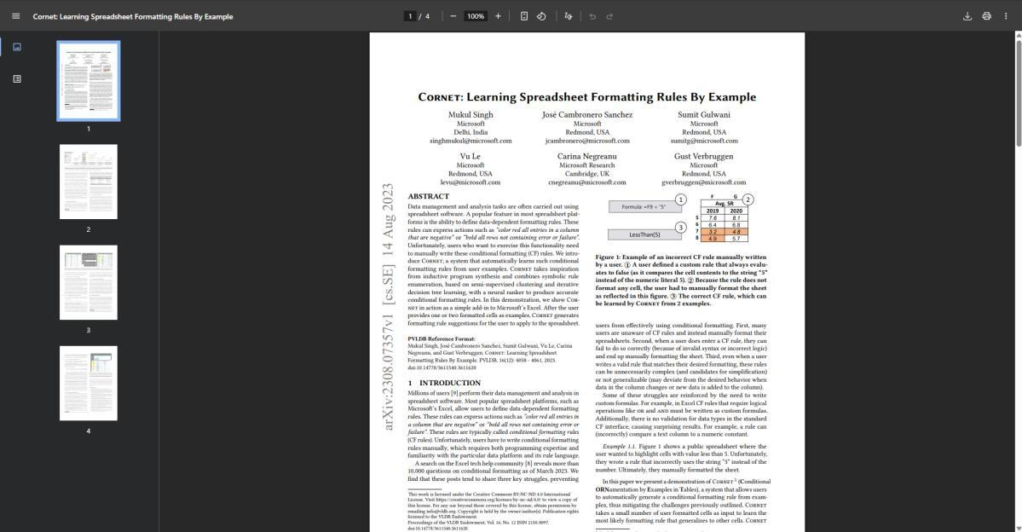
Figure 2: Comet
Cornet is a system developed by Singh et al. (2023) that automatically learns conditional formatting rules from formatted cells that users provide as examples within spreadsheets. By combining symbolic rule enumeration with a neural ranker, Cornet suggests formatting rules to users without requiring them to understand the underlying rule language themselves, and has been demonstrated as a working add-in to Microsoft Excel. The primary appeal of Cornet lies in its ability to generalize a formatting pattern from just a handful of manually formatted examples, making it especially useful for users who work heavily with structured, tabular data.

In contrast, IntelliDocs applies behavioral learning to free-form academic manuscripts rather than spreadsheet cells. Instead of requiring users to manually supply formatted examples, IntelliDocs passively tracks keystrokes and formatting actions in the background as a user writes, learning their styling habits without interrupting their drafting flow. This makes IntelliDocs better suited for the continuous, sequential nature of manuscript writing, offering a non-intrusive co-pilot experience rather than a rule-generation tool confined to tables

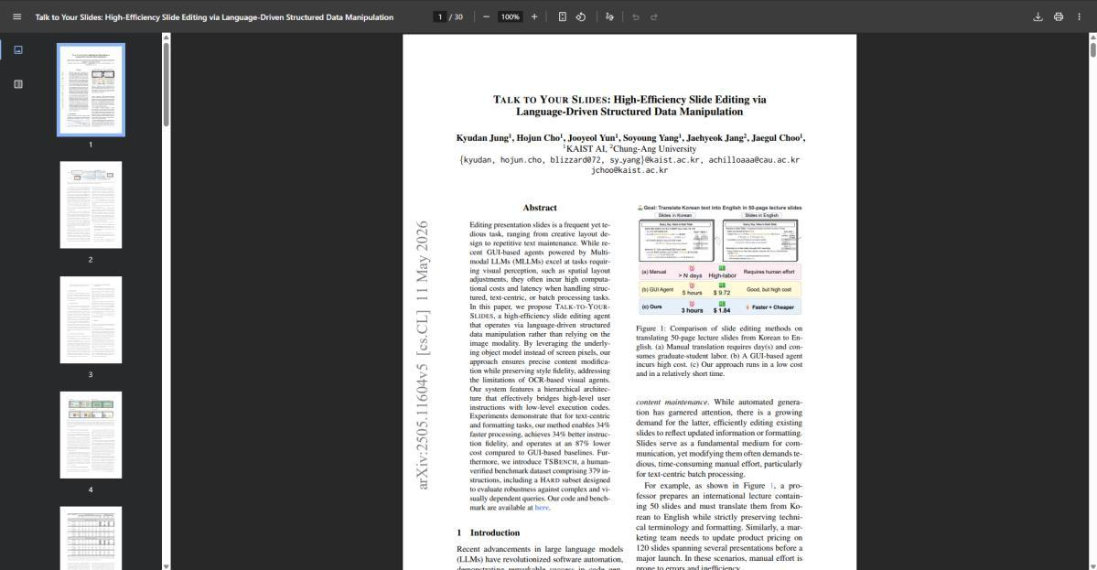
Talk-To-Your-Slides

Figure 3: Talk-To-Your-Slides

Talk-to-Your-Slides is a hierarchical, LLM-powered agent developed by Jung et al. (2026) that edits presentation slides through natural language instructions by directly manipulating structured slide objects rather than relying on screen pixels or image-based recognition. Its language-driven structural agent enables 34% faster processing, 34% better instruction fidelity, and 87% lower cost compared to GUI-based baselines that rely on visual perception. The primary appeal of Talk-to-Your-Slides lies in how efficiently it executes large-scale structural edits across a slide deck using plain-language commands, avoiding the latency and cost of vision-based agents entirely.
In contrast, IntelliDocs extends this language-driven editing approach to text-heavy academic manuscripts rather than visual slide decks. Beyond executing one-off batch edits, IntelliDocs integrates an LSTM neural network that learns and predicts a specific author's recurring structural patterns over time. This gives IntelliDocs a personalization layer that Talk-to-Your-Slides lacks, ensuring layout consistency across an author's documents rather than treating each editing request as an isolated task.

CoEdIT
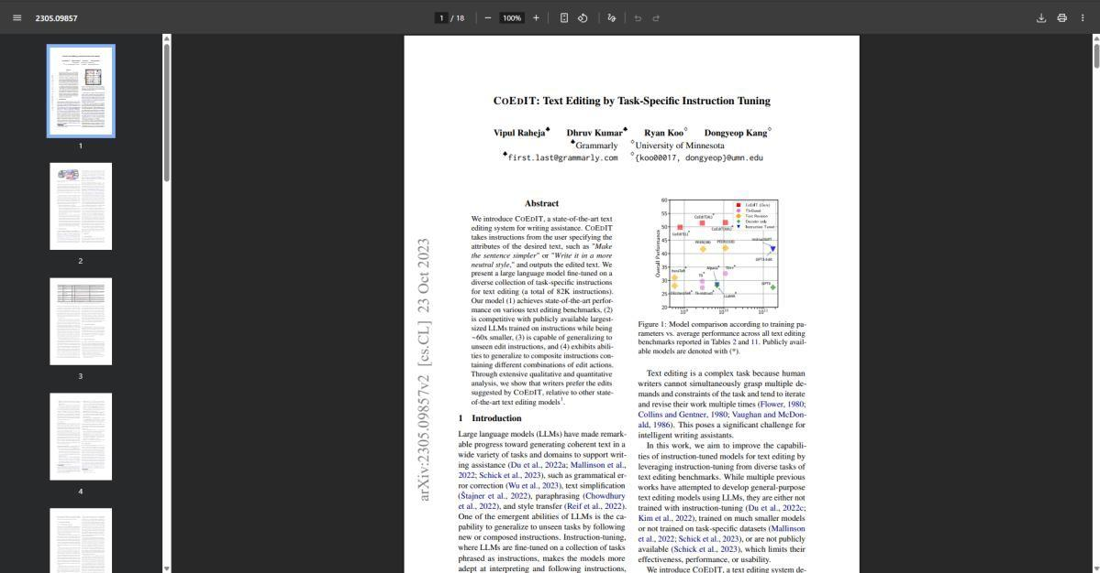Figure 4: CoEdIT
CoEdIT is an instruction-tuned large language model developed by Raheja et al. (2023) specifically for text editing tasks, designed to generalize across a wide range of instruction types — such as simplification, paraphrasing, and grammatical correction — rather than being narrowly trained for a single editing task. The primary appeal of CoEdIT lies in its ability to handle diverse editing instructions through a single generalized model, avoiding the need for separate specialized models for each type of text transformation.
In contrast, IntelliDocs focuses specifically on structural and stylistic formatting rather than general-purpose text editing instructions. While CoEdIT generalizes across content-level edits like rewording and grammar correction, IntelliDocs is built around a personalization loop — using an LSTM and behavioral tracking to learn an individual author's formatting habits over time — giving it a persistent, user-specific adaptation layer that a general-purpose instruction-tuned editing model does not maintain across sessions.

DocEdit-v2
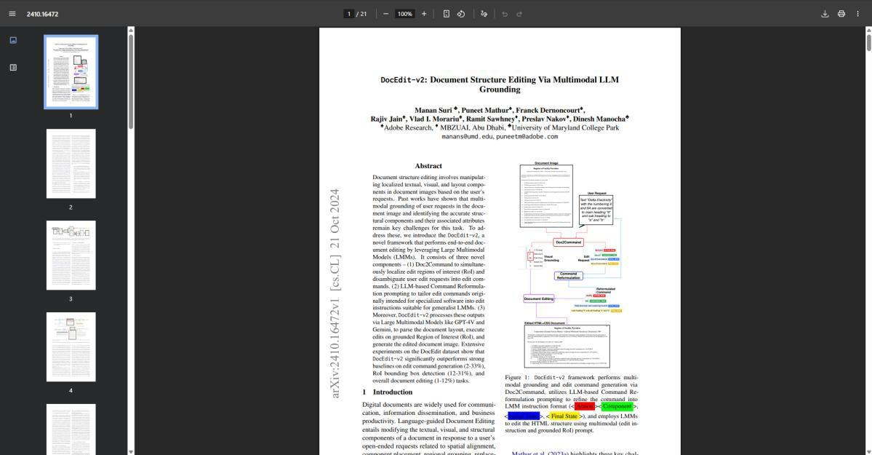
Figure 5: DocEdit-v2
DocEdit-v2 is a framework developed by Suri et al. (2024) that performs language-guided document editing by grounding open-ended natural language requests to specific components within a document's structure. The system uses a "Doc2Command" module to interpret ambiguous user requests, refines them through LLM-based command reformulation, and then edits the document's underlying HTML structure using multimodal prompting that combines the edit instruction with the visually grounded region of interest. The primary appeal of DocEdit-v2 lies in its ability to resolve vague, open-ended editing requests into precise, executable commands targeting the correct part of a document, even when the user's phrasing doesn't explicitly name what they want changed.
In contrast, IntelliDocs resolves natural language formatting commands against a flat key-value block structure rather than a visually grounded HTML/image representation. This allows IntelliDocs to apply bulk formatting changes, such as "bold all headings," directly across matching content blocks without needing multimodal visual grounding, making the system lighter-weight and better suited for real-time collaborative editing where the document is a live, continuously changing text document rather than a static visual layout.

ReWriteLM
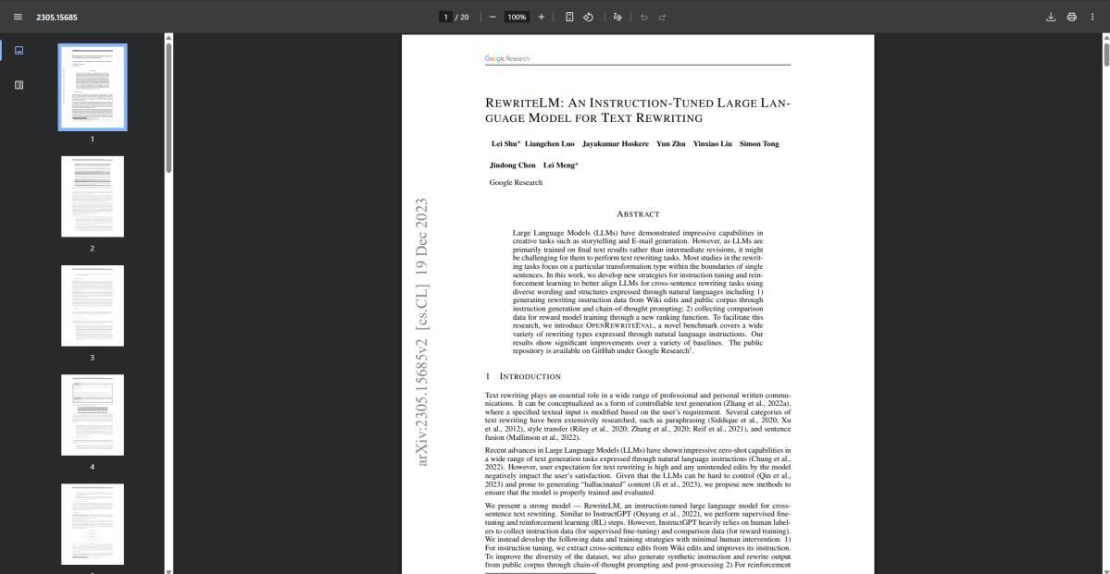
Figure 6: ReWriteLM
RewriteLM is an instruction-tuned large language model developed by Shu et al. (2023) for long-form, cross-sentence text rewriting, built to follow natural language instructions such as adjusting tone, formality, or conciseness across full passages rather than isolated sentences. The authors also introduce OpenRewriteEval, a benchmark covering a wide variety of rewriting types, and show that RewriteLM significantly outperforms baseline LLMs while minimizing hallucinated content that drifts from the original meaning. The primary appeal of RewriteLM lies in its reliability for long-form content rewriting, preserving the essential meaning of a passage while still executing the requested stylistic transformation.
In contrast, IntelliDocs is not concerned with rewriting the content or meaning of a manuscript at all — its natural language commands target structural and visual formatting (headings, citation styles, spacing) rather than wording or tone. This distinction matters for academic writing specifically, where preserving the author's original phrasing is often a requirement rather than a risk to manage, and where the harder problem IntelliDocs solves is precisely targeting which structural elements to reformat rather than generating new rewritten text.

COMPARATIVE MATRIX
This comparative matrix presents an overview of all the inter-related studies and the web-based platform that are inter-related with IntelliDocs. The attributes compare IntelliDocs and other web-based platforms that also exhibit the same as IntelliDocs.
Table 1
COMPARATIVE MATRIX

Features | IntelliDocs | Cornet (Singh et al., 2023) | Talk-To-Your-Slides (Jung et al., 2026) | CoEdIT (Raheja et al., 2023) | DocEdit-v2 (Suri et al., 2024) | RewriteLM (Shu et al., 2023)
Behavioral Tracking & Feature Extraction (Barkan et al., 2023; Li et al., 2021) | ✓ | ✓ | ⨯ | ⨯ | ⨯ | ⨯
Machine Learning Prediction Engine (Singh et al. (2023) | ✓ | ✓ | ✓ | ✓ | ✓ | ✓
User Transparency & Suggestion Presentation (Wang & Yin 2021) | ✓ | ✓ | ⨯ | ⨯ | ✓ | ⨯
Natural Language Command Interface (Zamani & Kraus, 2022) | ✓ | ⨯ | ✓ | ✓ | ✓ | ✓
Continuous Improvement & System Learning (Park & Nakamura, 2024; Singh &  Martinez, 2023; Heo  & Lee, 2023) | ✓ | ⨯ | ⨯ | ⨯ | ⨯ | ⨯
User Outcomes & Productivity Benefits (Wang et al., 2023) | ✓ | ✓ | ✓ | ⨯ | ⨯ | ✓

IntelliDocs introduces an adaptive approach to word processing by embedding machine learning directly into the document editor. While traditional applications treat layout design as a strictly manual chore, this platform captures a writer's unique styling habits through behavioral formatting learning. It views editing history as a sequence of distinct patterns. A hybrid prediction engine evaluates these telemetry records in real time to generate automated formatting suggestions. These inline hints are completely non-intrusive. Every recommendation is paired with a clear confidence score to maintain absolute transparency before any style is applied. The system does not stay static. When a researcher interacts with the workspace, the software adapts through supervised fine-tuning, using the user's explicit acceptance or rejection of suggestions as labeled feedback to drive continuous learning. For broader, sweeping layout changes across a manuscript, authors can execute multi-step operations instantly using a natural language command interface. It fundamentally alters the writing workflow. By bridging the gap between raw drafting and automated typography, the platform transforms a traditional text canvas into a highly personalized, intelligent co-pilot.

